Discussion Assignment Unit 1
Question 1: Explain why you selected this personality trait and discuss two key characteristics of this trait that you believe will enhance your leadership skills.
I did a Big Five Personality test with the openpsychometrics.org, and my PIP Big Five Factor Markers were as shown below.
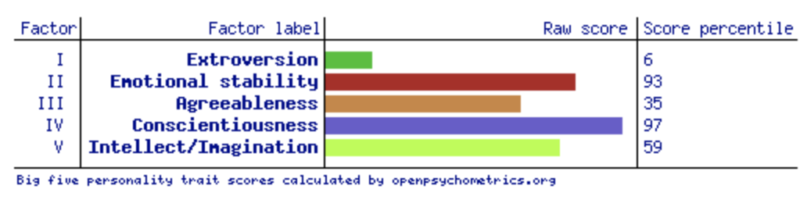
I had the highest score in conscientiousness, and that is how I selected this personality trait. According to the result, one of the key characteristics of conscientious people is being reliable, hardworking, and efficient. They tend to be well-organized and responsible and are motivated to achieve their goals (openpsychometrics.org, 2025). Reliability ensures that I am dependable and trustworthy, qualities that inspire confidence among team members and enable me to deliver on commitments effectively. This creates a foundation of mutual respect and fosters a collaborative atmosphere. Meanwhile, meticulous organization enables me to manage responsibilities efficiently, set clear goals, and structure workflows that optimize productivity. Such organizational skills are pivotal in navigating complex projects and maintaining focus amidst challenges. Together, these traits not only enhance my ability to lead but also empower me to cultivate a positive, goal-oriented environment for those I work with.
Moreover, conscientious people are also characterized by a strong sense of self-discipline and perseverance. For instance, they are more likely to engage in health-promoting behaviors, such as exercising regularly and maintaining a healthy diet. On the same note, they tend to have better academic and job performance, as well as lower rates of absenteeism and turnover (openpsychometrics.org, 2025). My conscientiousness improves my leadership by enabling me to plan carefully, focus on details, and stay committed to my responsibilities. I set clear goals, uphold high standards, and build trust within my team. My self-discipline ensures I lead by example and am dependable, while my perseverance helps me overcome obstacles and adapt effectively. I also prioritize overall well-being by engaging in health-promoting habits like regular exercise and maintaining a balanced diet, which boosts productivity and resilience. My academic and professional excellence lead to consistent performance, reducing absenteeism and turnover. Ultimately, my conscientiousness fosters collective growth and ambition.
Question 2: With the help of an example, share two skills that you believe will help you interact with and manage individuals who have different personality traits than your own.
I scored lowest in extroversion, meaning I prefer to spend time alone or in small groups, and may feel uncomfortable in large social gatherings. Introverted people may also be less assertive and more cautious in their interactions with others (openpsychometrics.org, 2025). Dealing with extroverted people would require me to utilize adaptability in communication and empathy. Adaptability enables me to adjust my approach based on the traits of others. For instance, when working with extroverted individuals, I create opportunities for group discussions and encourage their active participation, recognizing their enthusiasm and valuing their input. This tailored communication style fosters collaboration and engagement. Empathy, on the other hand, helps me understand and respect others’ perspectives. For example, when dealing with introverted individuals, I schedule one-on-one meetings to ensure a comfortable environment where they can share thoughts without pressure. This empathetic approach builds trust and mutual understanding, enabling effective collaboration. By employing these two skills, I bridge gaps between differing personality traits, fostering harmony and productivity within my team while encouraging a supportive and inclusive work environment.
References

openpsychometrics.org. (2025). Results summary. https://openpsychometrics.org/tests/IPIP-BFFM/results.php?r=1.6,4.2,3.5,4.8,4#_IV

